Real Time Network Intrusion Detection using Machine Learning Technique
*Note: Sub-titles are not captured in Xplore and should not be used

Adrian Dsouza
Department of Computer Engineering MCT Rajiv Gandhi Institute of Technology
Mumbai, India
adriandsouza2504@gmail.com
Vedant Lanjewar
Department of Computer Engineering MCT Rajiv Gandhi Institute of Technology
Mumbai, India
vedant.edu9@gmail.com
line 1: 5th Given Name Surname
line 2: dept. name of organization
(of Affiliation)
line 3: name of organization
(of Affiliation)
line 4: City, Country
line 5: email address or ORCID
Abhishek Mahakal
Department of Computer Engineering MCT Rajiv Gandhi Institute of Technology
Mumbai, India
line 5: email address or ORCID

Abstract—This paper reflects the work carried out in network security using different machine learning techniques. In response to the exponential increase in network space breaches and data leaks, the demand for a system that can detect anomalies and notify the system admin is imperative. Using packet sniffing modules, we capture the packets and then compare it to a pre-trained machine learning module trained on the NSL KDD dataset to detect ambiguous packets. By selecting the desired port, the IDS sniff all incoming packets and categorizes it as anomalous if its behavior isn’t normal. On successful prediction we present the user with a choice if to take action against the prescribed threat or ignore it as per the user’s request. A detailed analysis report shall then be presented periodically to provide an overview of the overall health of the system on which our IDS system has been deployed.
Keywords—packet-sniffing, real time intrusion, decision tree, network packets, NSL KDD, Intrusion Detection System, Anomaly Detection, cyber security, packet sniffing, DDOS, firewall.

Introduction
The rapid growth in the use of computer networks and digital technologies has resulted in the issue of maintaining network availability, integrity, and confidentiality. Protection of data in a network-based computer system has become a major challenge in the world today. With the ever-increasing digital traffic, hackers and malicious user’s new ways of penetration and network intrusion takes place. Network intrusion has predominantly increased following the rapid growth of internet technologies in different areas of social networking, e-learning, e-business, e-education and digitalization. This has put the security of various organization be it a large-scale multinational firm or a local startup, all are vulnerable and are at risk. An intrusion detection system (IDS) is developed which will detect attacks in a computer network, also monitoring the network and protecting it from the intruder.
- As part of this research, the NSL KDD Test datasets were analyzed and used for training our model and setting the standards and parameters. Machine learning algorithms such as Naïve Bayes, Support Vector Machines (SVM), Random Forest, and Decision Tree were applied to determine the best accuracy for our IDS-System by classifying these attacks as anomaly or non-anomaly. Analyzing huge network traffic data is the main work of intrusion detection systems. PyShark a python library that captures the network traffic for us and presents us with packets which has various attributes coupled along with it. We then pass it through our model and get a predicted score for the current packet. If its score is beyond the set threshold, we have an intrusion else we continue to scan the network.

Introduction to Intrusion Detection System (IDS)
An intrusion detection system (IDS) is a device or software application that monitors a network for malicious activity or policy violations. Firewalls and anti-malware programs alone are not enough to protect an entire network from an attack. A well-rounded security strategy should also include an intrusion detection system (IDS) that pinpoints suspicious traffic once it passes the firewall and enters the network. IDS is known as the second line of defense to detect anomalous traffic at the physical and network layer after it has passed through the firewall and other security appliance on the border of the network.
There are two detection methods of IDS.
- Signature based – Based on the previous malicious attacks, the IDS system will compare the patterns in the current packets and if a match is found, we declare it as malicious.
- Anomaly based – The downside of the signature based was if the attack was a new one, which hasn’t been previously recorded it can go undetected, so to overcome this we have the anomaly-based IDS system. Advance ML/AI algorithms are used to see if the incoming traffic is suspicious or not suspicious.

Designing an Anomaly based intrusion detection system.
With a wide variety and new forms of attacks, predefined set of patterns and signatures to represent such attacks becomes impossible. Signature based systems cannot distinguish normal and malicious packets for which it doesn’t have any signatures or patterns. So, to develop our system and to handle newer attacks, we have worked with the anomaly-based detection techniques. So, we have to train our anomaly detection system using some machine learning or deep learning or AI algorithm. We have two phases in this process, training phase (we teach what is normal behavior) and testing phase (current traffic is compared with the normal behavior as per our data). The classifier will then use a mathematical model to check for any deviation from what is called a normal behavior and then accordingly will raise an alarm.

For Whom Is This System
This System is designed to protect various organizations and institutes from various attacks.
- Big companies dealing with loads and loads of data and public information
- Schools, colleges, universities holding sensitive student information. Competitive exams papers all on their servers
- Healthcare systems
- Banking and cryptocurrency sector
- Private networks and crucial services

Objective
- To create a software to sniff incoming packets
- To collect the incoming packets and categorize them as safe or unsafe
- To use advance machine learning algorithms to classify the traffic
- Obtain a good accuracy in predicting the incoming packets
- Create a user-friendly interface and design
- Notify users in case of an attack

Scope
Network Intrusion Detection can be used to protect the given private or open network from attackers present on the world-wide network. This NIDS can be employed in universities to secure papers and student confidential data, Healthcare systems to add another level of security to prevent tampering or extraction of patient records.

Proposed System
- The proposed model consists of using learning algorithms like Support Vector Machine(SVM), Naive Bayes, Random Forest, and Decision tree.
- The main aim behind the proposed model is to extract the common features between the NSL-KDD dataset and packet sniffer and train those features for real-time intrusion detection.
- Using Packet Sniffer, real-time sniffing of packets takes place, whose features go through our trained model. We are able to extract 7 out of the 42 features using the Pyshark python library by scanning all incoming traffic on our host. We are able to identify the IP address, the type of packet, and the current services being used.
- Using this we plan to identify if the packet is normal or abnormal based on the 7 features and then ascertain ourselves by seeing if its behavior is different from what is considered normal.
- There will be 2 classes: Normal and Abnormal. Abnormal would be further classified into DoS, Probe, U2R, R2L attacks with increased accuracy.

System Design and Architecture
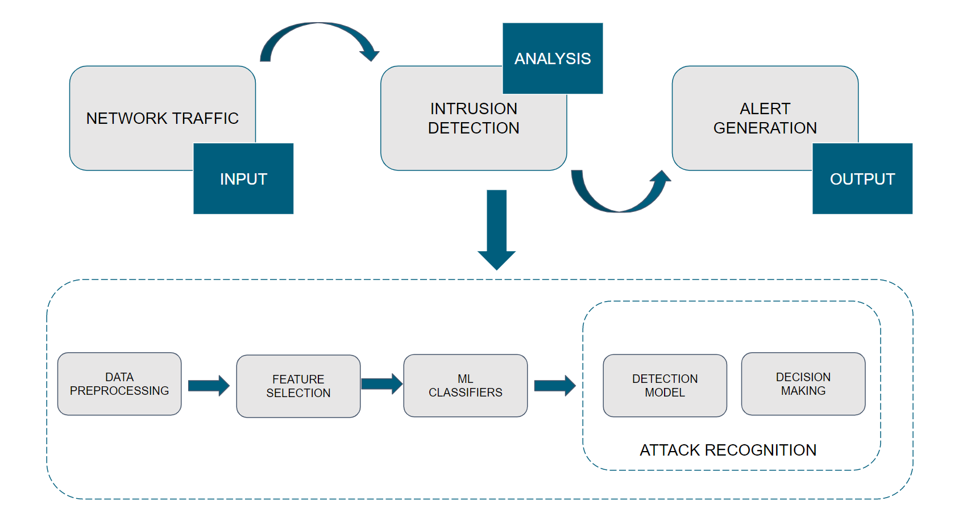

Fig 1: System Architecture of an Intrusion Detection System

System design of this Intrusion Detection System shows the relation of the deployed model with the incoming packets and the alert generation system The basic interaction between the user and the product and how the packets are classified based on real world analysis is shown.

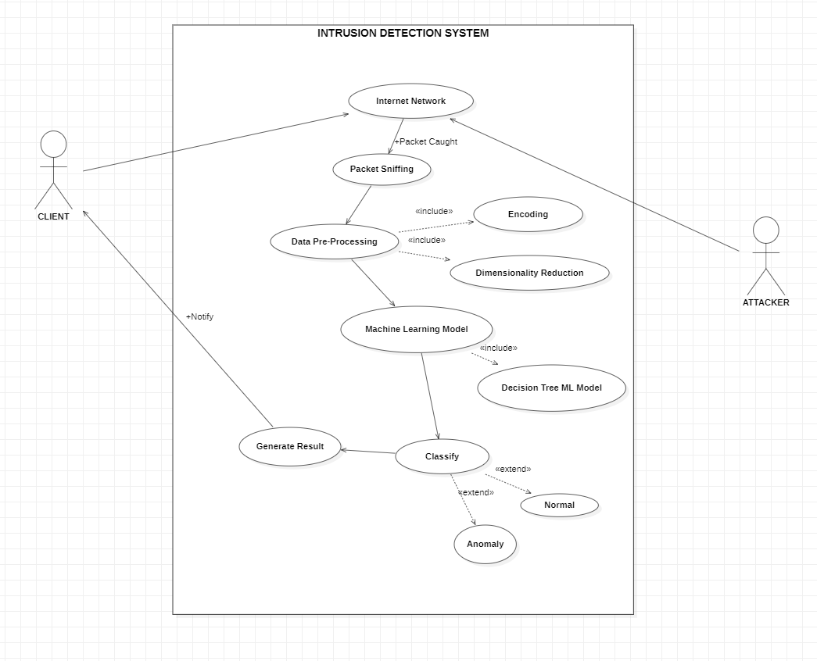

Fig 2: IDS Use Case Diagram
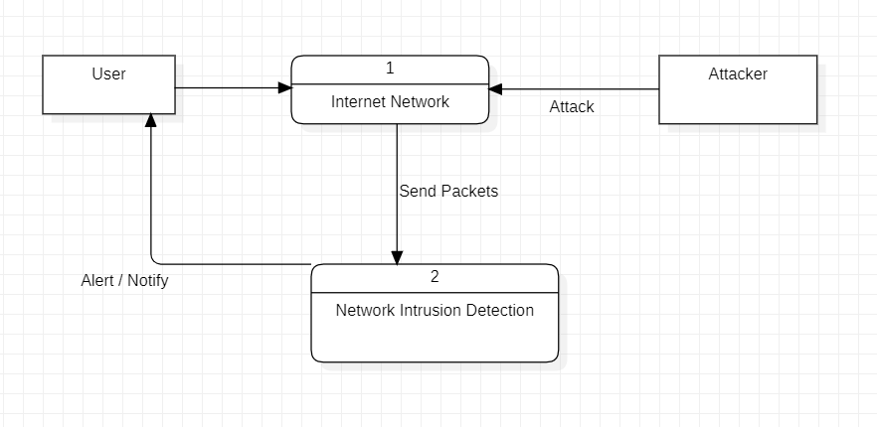

Fig 3: IDS Level 0 DFD Diagram

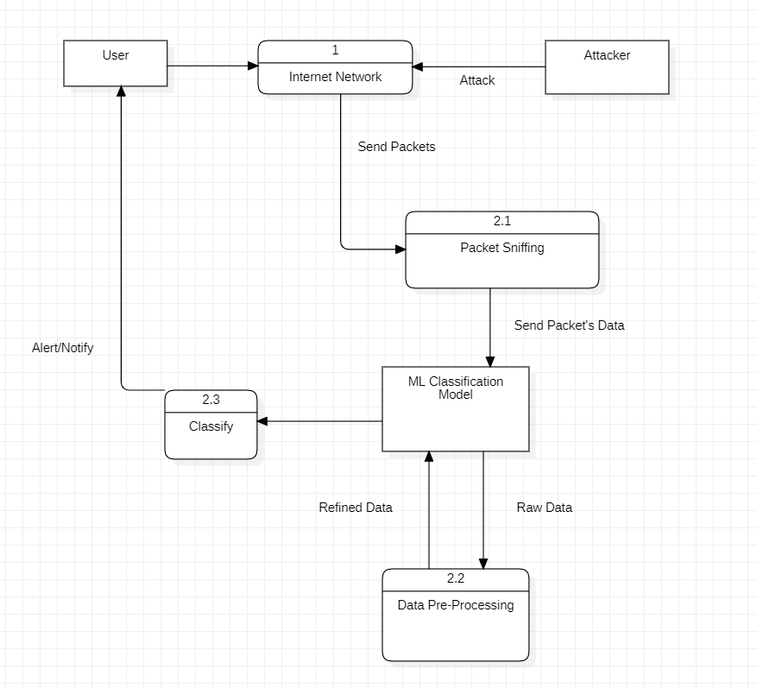

Fig 3: IDS Level 1 DFD Diagram

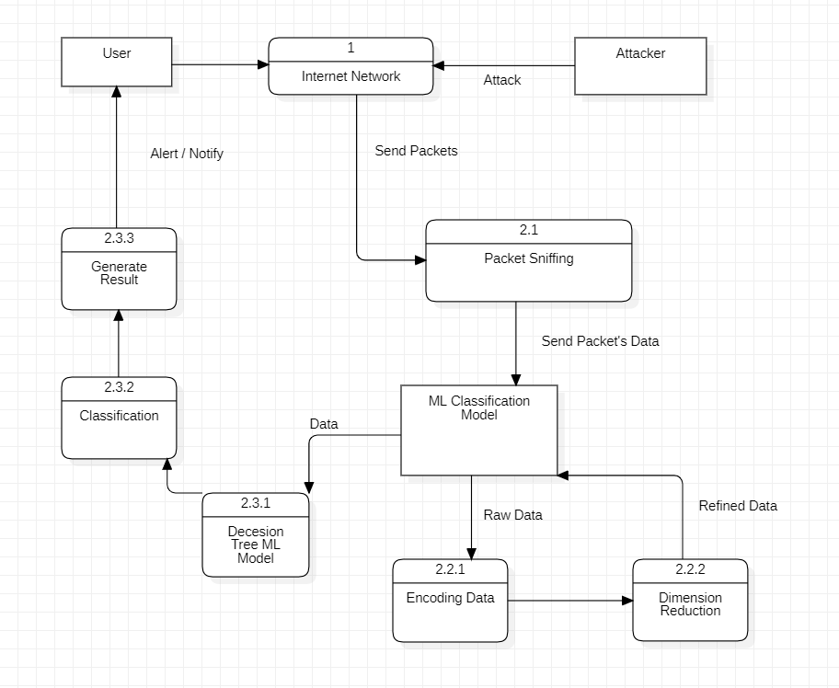

Fig 3: IDS Level 2 DFD Diagram

Using Machine Learning Algorithms

We need to successfully classify the packets based on the deviation the current data has with respect to the train data that is the NSL – KDD dataset.
The proposed model consists of using learning algorithms like Support Vector Machine (SVM), Naive Bayes, Random Forest, Logistic Regression and Decision tree.

Random Forest Regressor
Random forest is a Supervised Learning algorithm that uses ensemble learning methods for classification and regression. The "forest" it builds is an ensemble of decision trees, usually trained with the “bagging” method. The general idea of the bagging method is that a combination of learning models increases the overall result. Random forest builds multiple decision trees and merges them together to get a more accurate and stable prediction. One big advantage of random forest is that it can be used for both classification and regression problems. RFs train each tree independently, using a random sample of the data. This randomness helps to make the model more robust than a single decision tree, and
less likely to overfit on the training data.
We can understand the working of the Random Forest algorithm with the help of the following steps-
- First, start with the selection of random samples from a given dataset.
- Next, this algorithm will construct a decision tree for every sample. Then it will get the prediction result from every decision tree.
- In this step, voting will be performed for every predicted result.
- At last, select the most voted prediction result as the final prediction result.

MOEDLS | ACCURACY | RMS | F1 SCORE | RECALL | PRECISION
RANDOM FOREST | 0.9911 | 0.094 | 0.9917 | 0.9944 | 0.9889

Support Vector Machine
A Support Vector Machine (SVM) is a supervised machine learning algorithm that can be employed for both classification and regression purposes. SVMs are more commonly used in classification problems. SVMs are based on the idea of finding a hyperplane that best divides a dataset into two classes, as shown in the image below. Support vectors are the data points nearest to the hyperplane, the points of a data set that, if removed, would alter the position of the dividing hyperplane. Because of this, they can be considered the critical elements of a data set.
MOEDLS | ACCURACY | RMS | F1 SCORE | RECALL | PRECISION
SVM | 0.6159 | 0.6196 | 0.4602 | 0.3067 | 0.9217

C. Naïve Bayes
Naive Bayes is a simple, yet effective and commonly-used, machine learning classifier. It is a probabilistic classifier that makes classifications using the Maximum A Posteriori decision rule in a Bayesian setting. It can also be represented using a very simple Bayesian network. Naive Bayes classifiers have been especially popular for text classification, and are a traditional solution for problems such as spam detection. The goal of any probabilistic classifier is, with features x(0) through x(n) and classes c(0) through c(k), to determine the probability of the features occurring in each class, and to return the most likely class. Therefore, for each class, we want to be able to calculate P(c(i) | x(0), …, x(n)). In order to do this, we use the Bayes rule. Recall that the Bayes rule is the following: very little explicit training in Naive Bayes compared to other common classification methods. The only work that must be done before the prediction is finding the parameters for the features’ individual probability distributions, which can typically be done quickly and deterministically. This means that Naive Bayes classifiers can perform well even with high-dimensional data points and/or a large number of data points.

P(A/B) = (P(B/A)*P(A)) / P(B)

MOEDLS | ACCURACY | RMS | F1 SCORE | RECALL | PRECISION
NAIVE BAYES | 0.874 | 0.3548 | 0.8897 | 0.9515 | 0.8354

D. Decision Tree
Decision tree is the most powerful and popular tool for classification and prediction. A Decision tree is a flowchart like tree structure, where each internal node denotes a test on an attribute, each branch represents an outcome of the test, and each leaf node (terminal node) holds a class label.

MOEDLS | ACCURACY | RMS | F1 SCORE | RECALL | PRECISION
DECISION TREE | 0.9911 | 0.094 | 0.9917 | 0.9924 | 0.9909

E. Logistic Regression
In statistics, the logistic regression (or logit model) is used to calculate the probability of a certain class or event taking place, such as probability of a team winning a match, of a cell being cancerous or not, etc. This can be extended to model several classes of events such as determining whether an image contains a flower, dog, elephant, etc. Each object being detected and analyzed in the image will be assigned a probability between 0 and 1, with a sum of one.

MOEDLS | ACCURACY | RMS | F1 SCORE | RECALL | PRECISION
LOGISTIC REGRESSION | 0.9085 | 0.3025 | 0.9156 | 0.9293 | 0.9023

Using Pyshark For Packet Sniffing
Python wrapper for tshark, allowing python packet parsing using wireshark dissectors. There are quite a few python packet parsing modules, this one is different because it doesn't actually parse any packets, it simply uses tshark's (wireshark command-line utility) ability to export XMLs to use its parsing. Pyshark features a few "Capture" objects (Live, Remote, File, InMem). Each of those files read from their respective source and then can be used as an iterator to get their packets. Each capture object can also receive various filters so that only some of the incoming packets will be saved.

Feature Selection And Analysis
From the NSL KDD Dataset and the packet’s data sniffed by the sniffer. We have found 7 common features between the dataset and the packet’s data, which would be used for training and testing of ML model. From the 24**(don’t remember the exact number) features we are using only 7 features. These are:-
1.
2.
3.
4.
5.
6.
7.

VII. Intrusion Detection And Presentation

VIII. Conclusion

Acknowledgment (Heading 5)
The preferred spelling of the word “acknowledgment” in America is without an “e” after the “g”. Avoid the stilted expression “one of us (R. B. G.) thanks ...”. Instead, try “R. B. G. thanks...”. Put sponsor acknowledgments in the unnumbered footnote on the first page.

References
The template will number citations consecutively within brackets [1]. The sentence punctuation follows the bracket [2]. Refer simply to the reference number, as in [3]—do not use “Ref. [3]” or “reference [3]” except at the beginning of a sentence: “Reference [3] was the first ...”
Number footnotes separately in superscripts. Place the actual footnote at the bottom of the column in which it was cited. Do not put footnotes in the abstract or reference list. Use letters for table footnotes.
Unless there are six authors or more give all authors’ names; do not use “et al.”. Papers that have not been published, even if they have been submitted for publication, should be cited as “unpublished” [4]. Papers that have been accepted for publication should be cited as “in press” [5]. Capitalize only the first word in a paper title, except for proper nouns and element symbols.

- Table Type Styles
Table Head | Table Column Head
Table Head | Table column subhead | Subhead | Subhead
copy | More table copyª
- Sample of a Table footnote. (Table footnote)

For papers published in translation journals, please give the English citation first, followed by the original foreign-language citation [6].

- G. Eason, B. Noble, and I. N. Sneddon, “On certain integrals of Lipschitz-Hankel type involving products of Bessel functions,” Phil. Trans. Roy. Soc. London, vol. A247, pp. 529–551, April 1955. (references)
- J. Clerk Maxwell, A Treatise on Electricity and Magnetism, 3rd ed., vol. 2. Oxford: Clarendon, 1892, pp.68–73.
- I. S. Jacobs and C. P. Bean, “Fine particles, thin films and exchange anisotropy,” in Magnetism, vol. III, G. T. Rado and H. Suhl, Eds. New York: Academic, 1963, pp. 271–350.
- K. Elissa, “Title of paper if known,” unpublished.
- R. Nicole, “Title of paper with only first word capitalized,” J. Name Stand. Abbrev., in press.
- Y. Yorozu, M. Hirano, K. Oka, and Y. Tagawa, “Electron spectroscopy studies on magneto-optical media and plastic substrate interface,” IEEE Transl. J. Magn. Japan, vol. 2, pp. 740–741, August 1987 [Digests 9th Annual Conf. Magnetics Japan, p. 301, 1982].
- M. Young, The Technical Writer’s Handbook. Mill Valley, CA: University Science, 1989.

IEEE conference templates contain guidance text for composing and formatting conference papers. Please ensure that all template text is removed from your conference paper prior to submission to the conference. Failure to remove template text from your paper may result in your paper not being published.

We suggest that you use a text box to insert a graphic (which is ideally a 300 dpi TIFF or EPS file, with all fonts embedded) because, in an MSW document, this method is somewhat more stable than directly inserting a picture.
To have non-visible rules on your frame, use the MSWord “Format” pull-down menu, select Text Box > Colors and Lines to choose No Fill and No Line.

